Kem Chan
CS 405 – Secure Coding
Sept 9, 2026
Assignment 2- SQL Injection Coding

Source Code
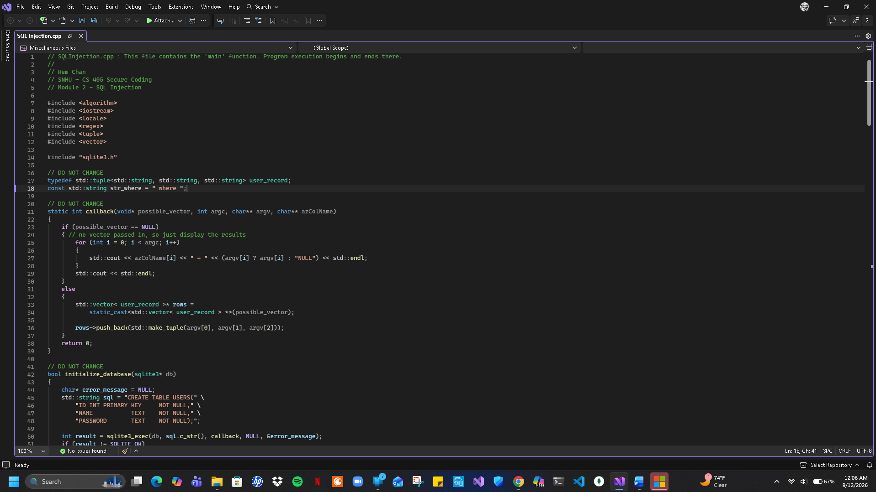
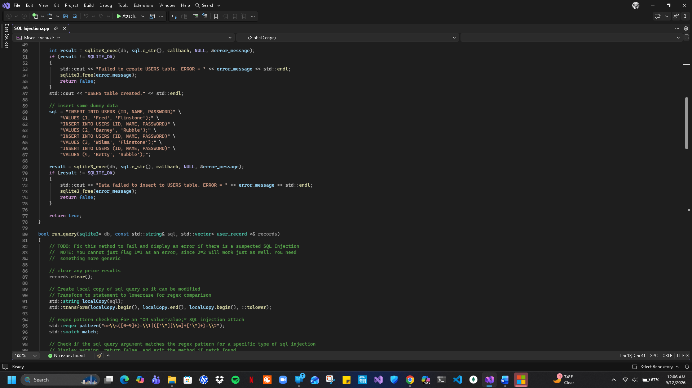
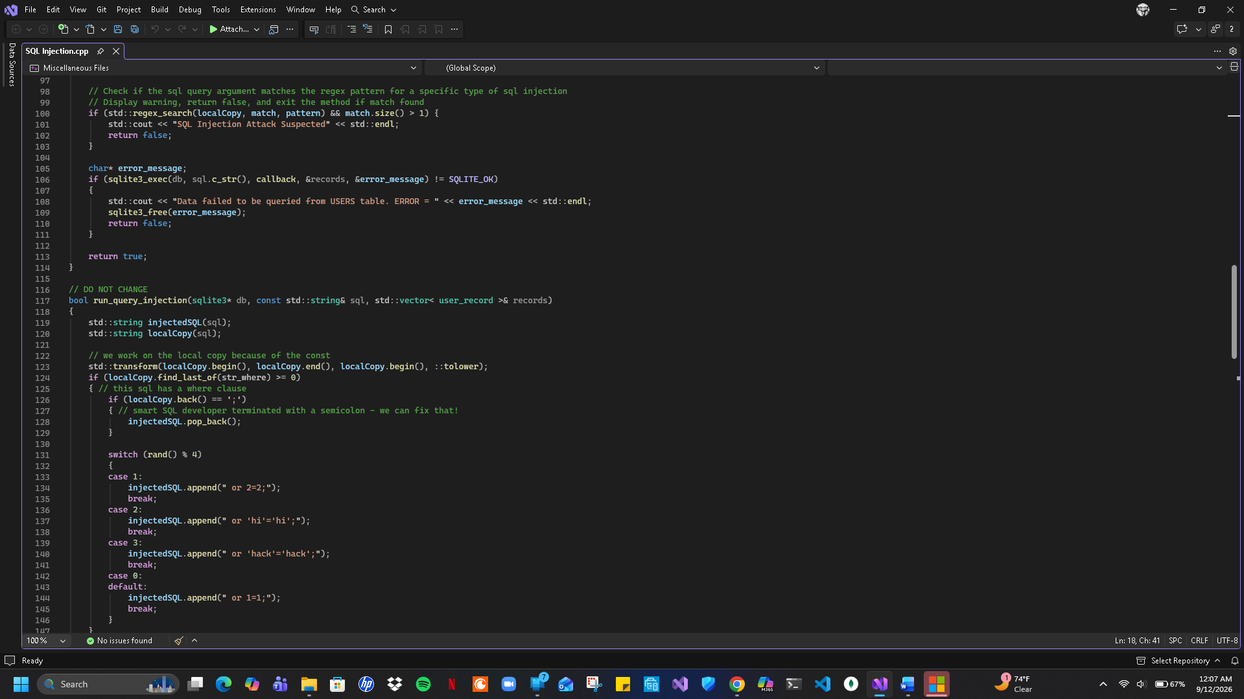
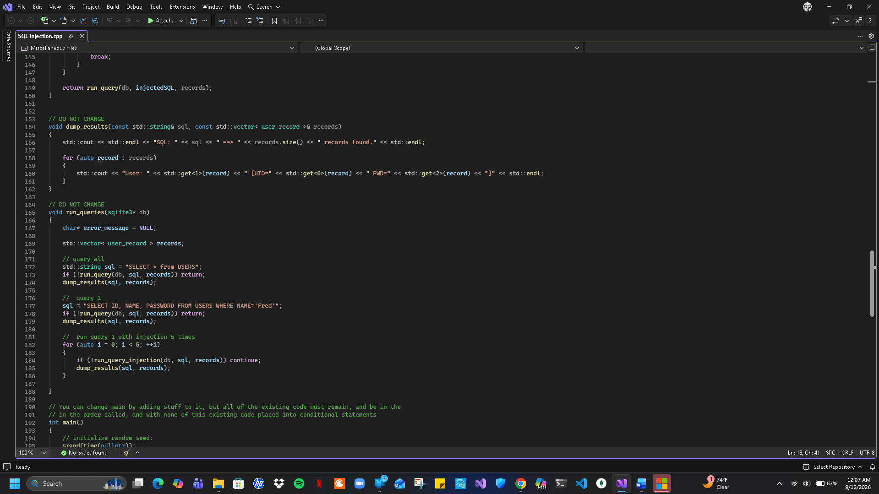
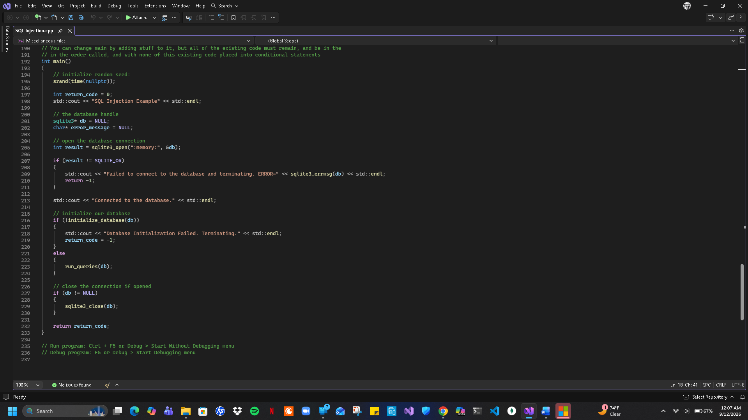

Output
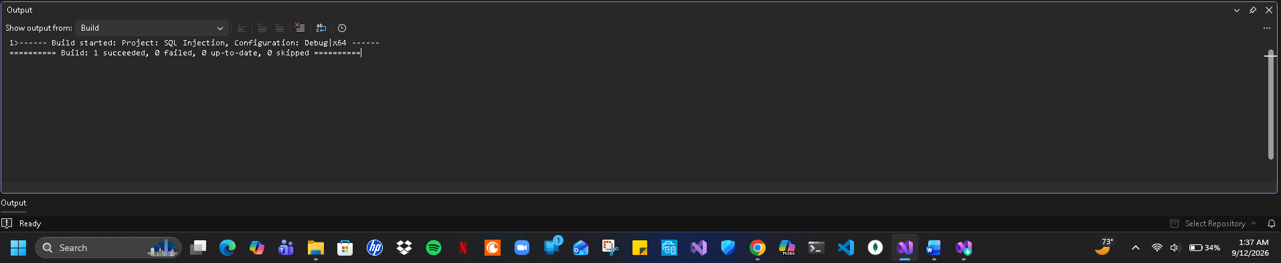
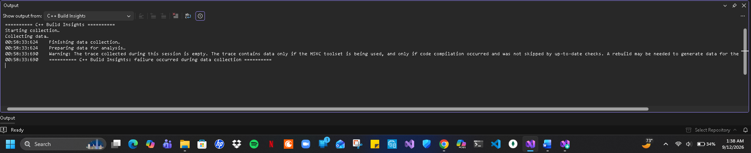
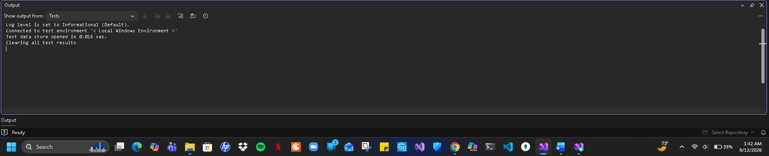

Summary
The assignment provided code that would create an internal memory database and would run multiple sets of queries with and without an SQL injection as well as dumping the results onto the console. This assignment occurs when an application takes the users’ input such as a username or password and directly concatenates it into a dynamic SQL query string without any validation or parameters. This application would pass through several modified strings so the database interpreter can change the query’s logic which allows the attackers to bypass authentications or dump sensitive user data or modify the content of the database. One approach attempted in executing this assignment was to try to normalize the system by converting SQL string to lowercase to also include any types of variations of the commands. While trying to normalize all SQL strings I also tried to include pattern matching by using simple string parsing or regular expressions that would look for suspicious syntax structures by also locating localized logic loops where a value would evaluate itself through matches. Lastly, to make sure all injection patterns that would be detected the program would send an output of the console warnings while logging the compromised query string and return false to block further executions.

